**Work Parties:**

**Purpose: Work parties used to send email Notifications & When adding Routings**

**Types of Parties:/ Party Roles**

***Operator/Owner: Sender  :***

***Recipient Parties are:***

***Person/Customer***

***Gov:***

***Com:***

***Org:***

**Every Party we will have Party Roles & Party Classes:**

**Operator/Owner:   Data-Party**

**Person: Data-Party-Person**

**Gov: Data-Party-Gov**

**Com: Data-Party-Com**

**Org: Data-Party-Org**

**From 7.4 Create Work Party & data transform under Data-Party Class & u can access properties from Data Class using Page Property:**

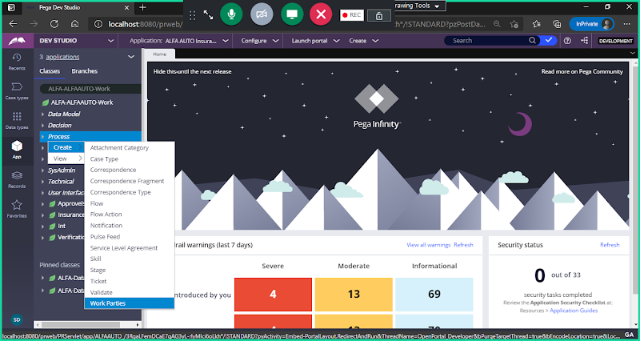

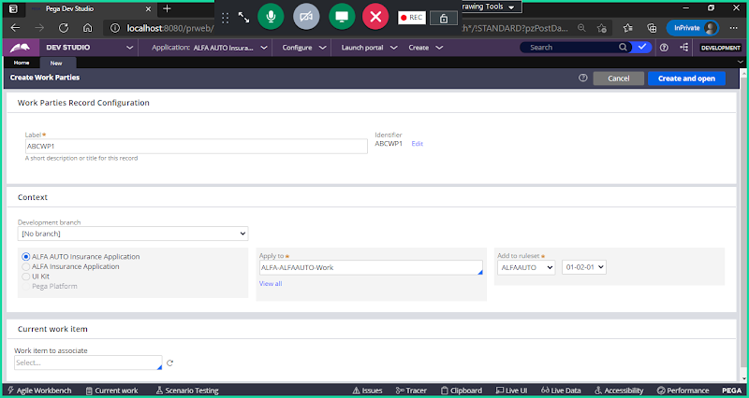

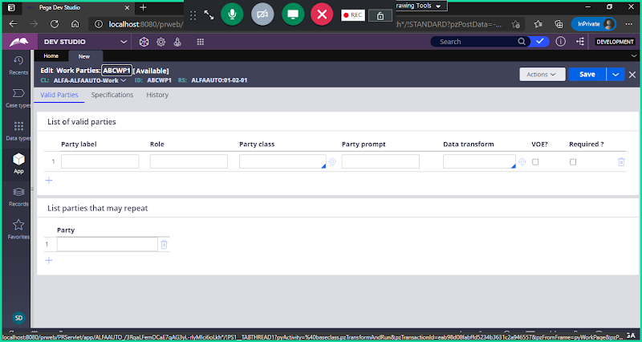

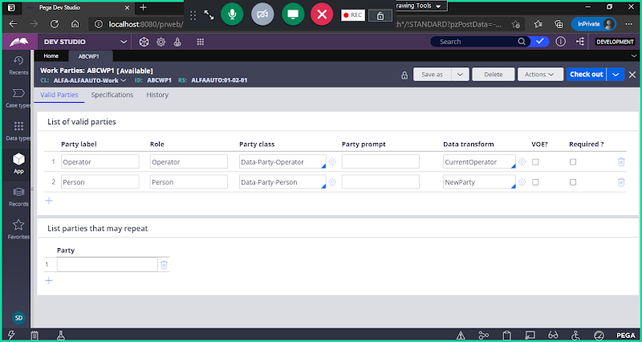

**Work Parties we can use in Sending Notifications & Routing**

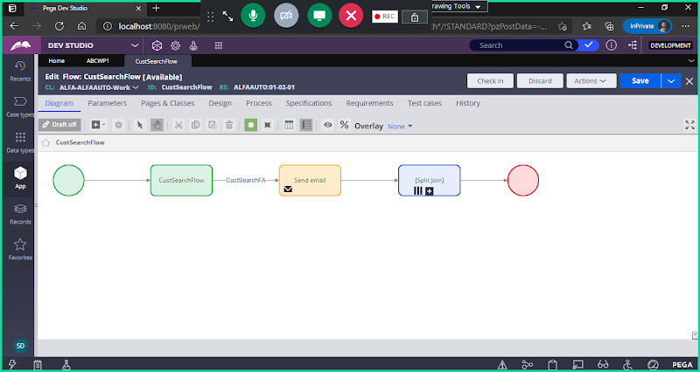

**From Send email Smart shape we can add Work Parties:**

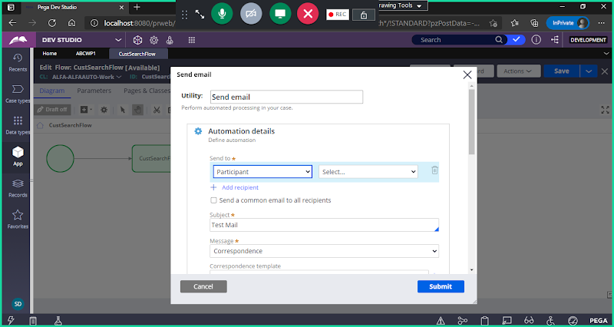

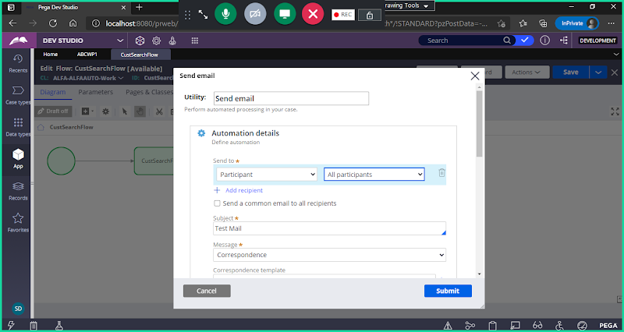

**Now Open Assignment Shape Properties:**

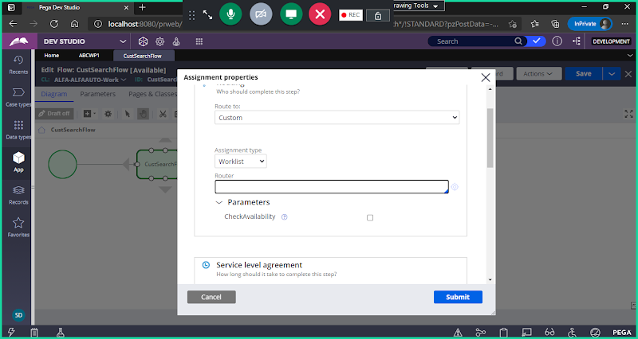

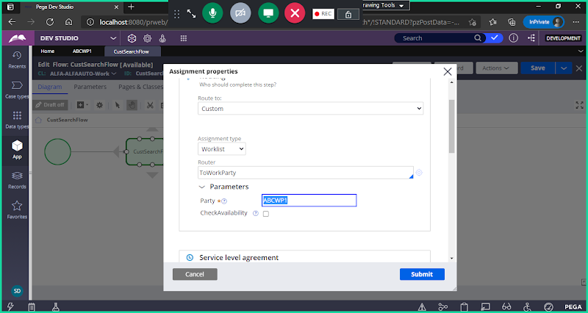

**To Send Notifications using WorkParties:**

**Open Assignment Shape Properties:**

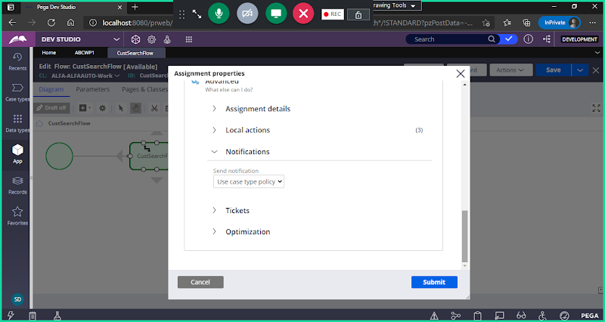

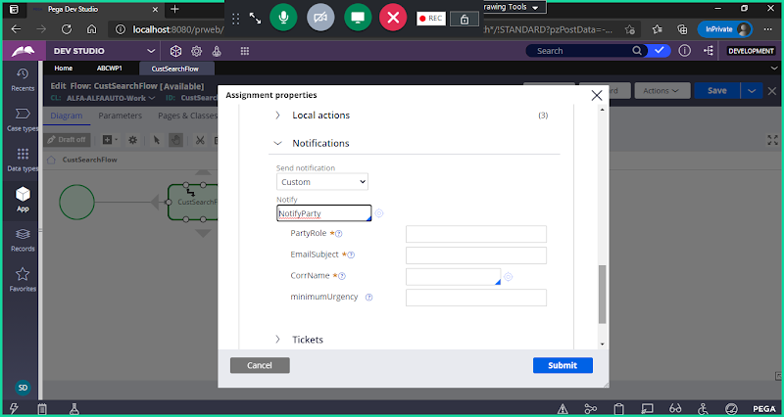

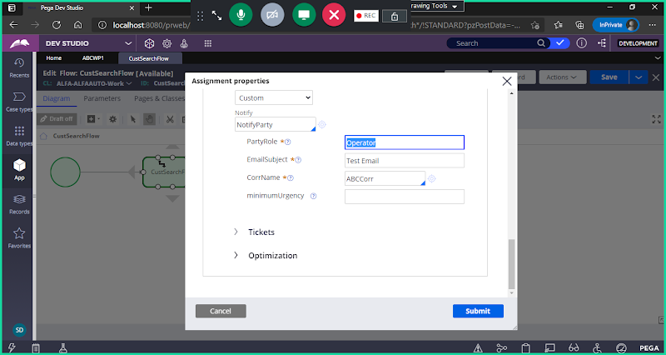

**==============**

**Exception Handling/Error Handling:**

**Connectors**

**Activities**

**Exception handling in Connectors:**

**Connection Problem Flow: (Built in Flow)**

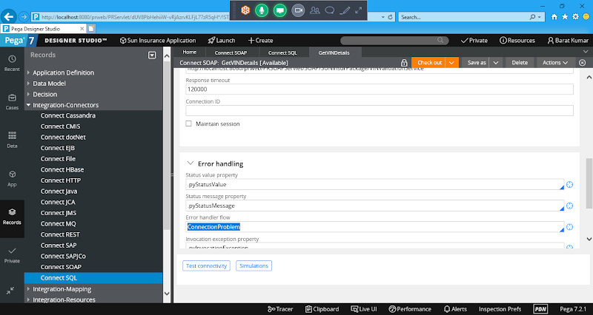

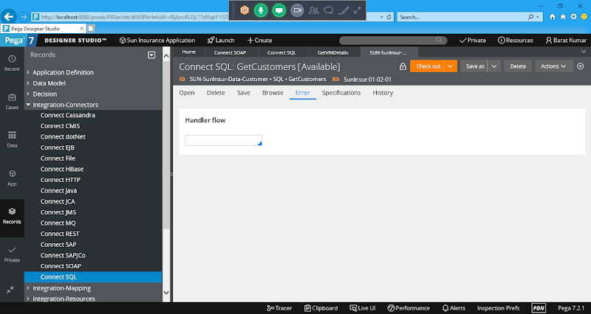

**Manually add the flow name:**

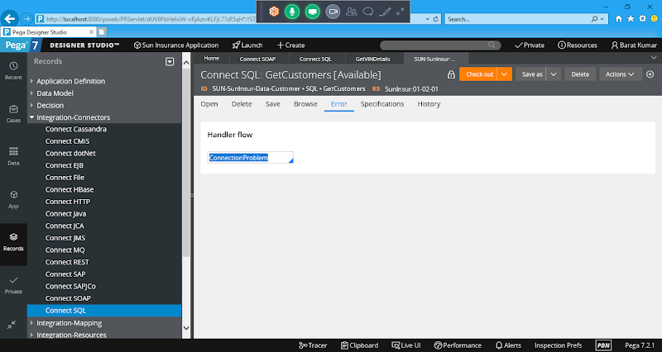

**Exception handling in Activities:**

**Create Paragraph Rule**

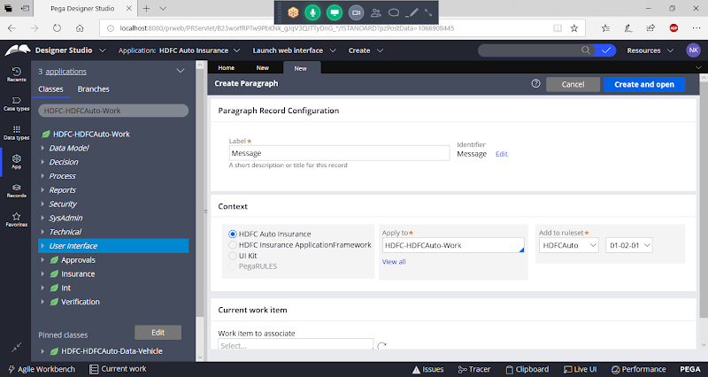

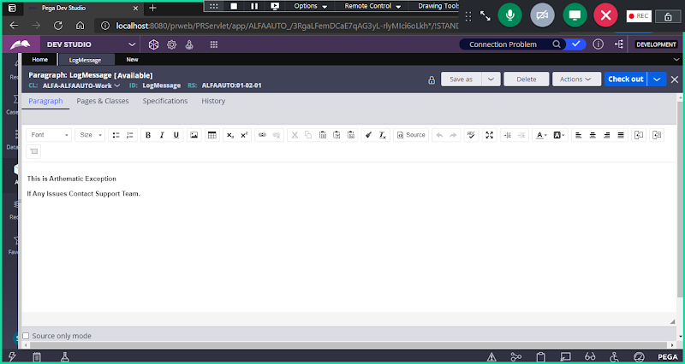

**Create a Section & Add Message in Section using Paragraph Rule & Call Section In Harness**

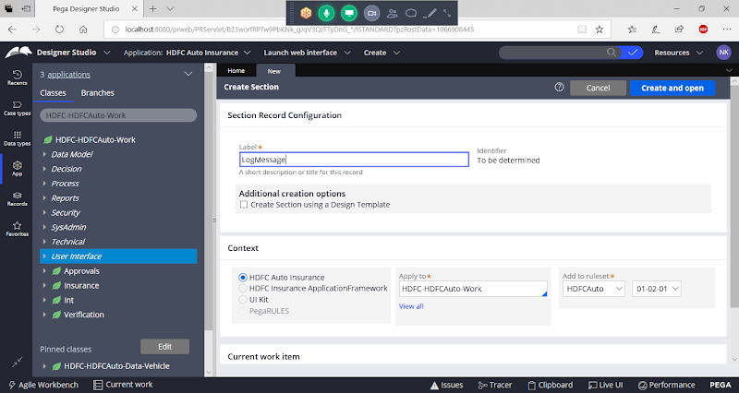

**Open & Add Paragraph Control from Advanced controls:**

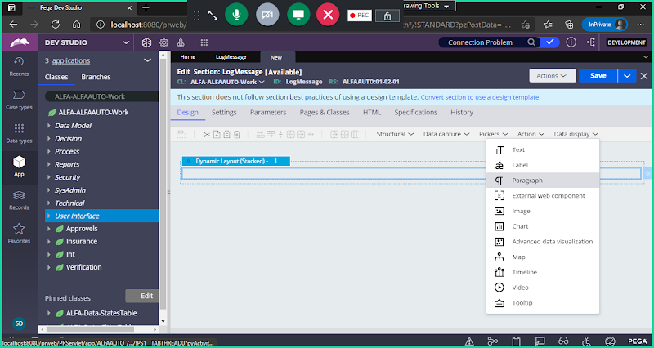

**Double click on Paragraph Control settings:**

**Give Name & Open Paragraph**

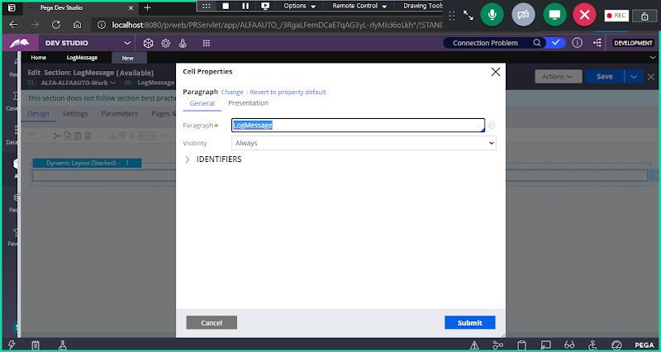

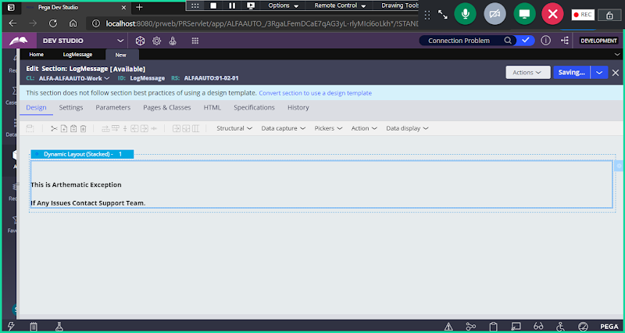

**Save Section**

**Create Harness:**

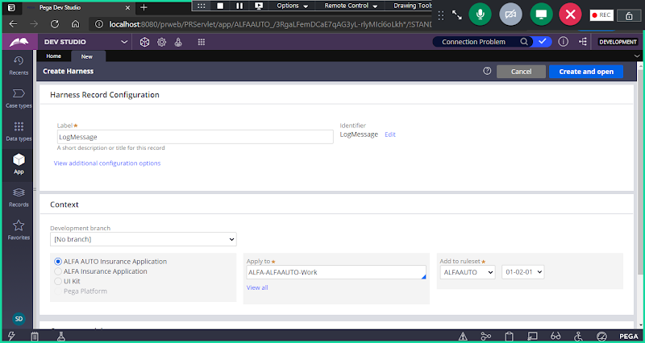

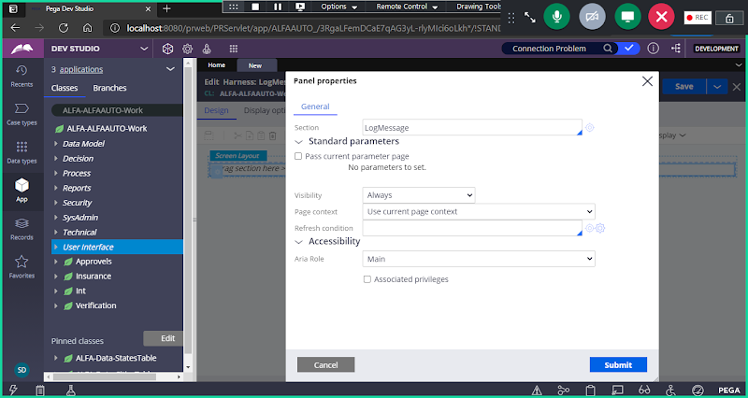

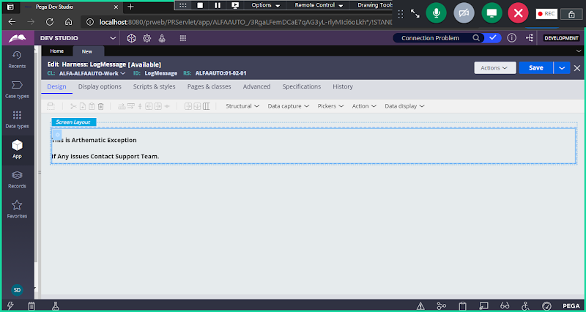

**=========**

**Create Activity Rule:**

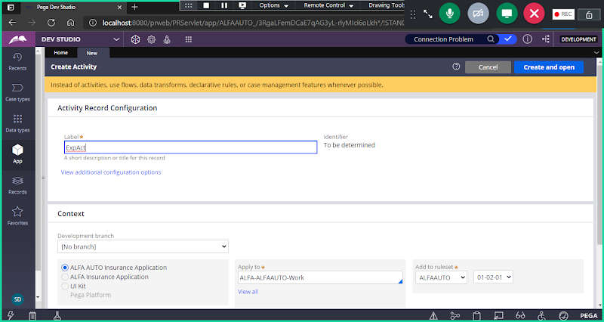

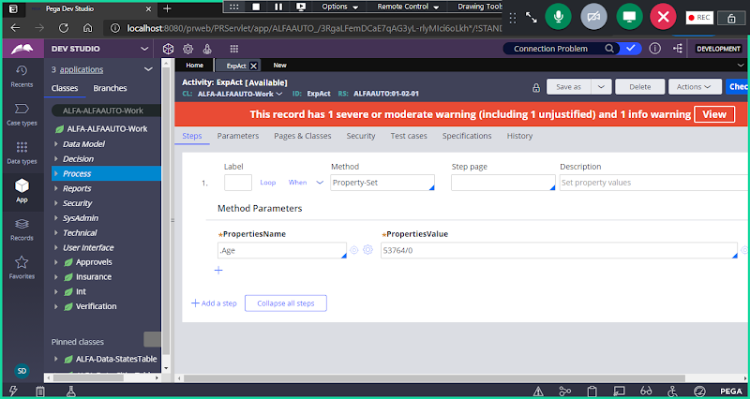

**Create a Flow:**

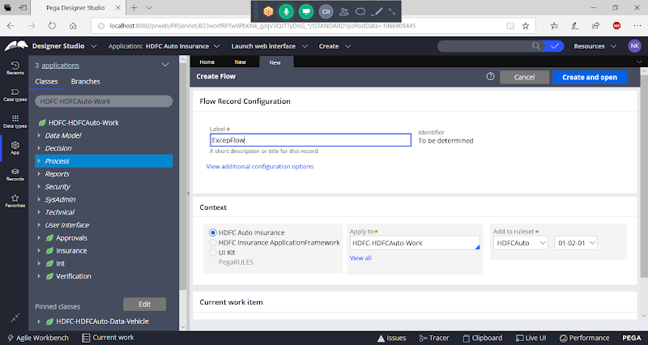

**Save & Run in flow**

**When we run Flow in server, it will give Java Run time Exception Message.**

**===**

**We can add some exception message in Activity and Call activity in application.**

**Open Activity & Add exceptions:**

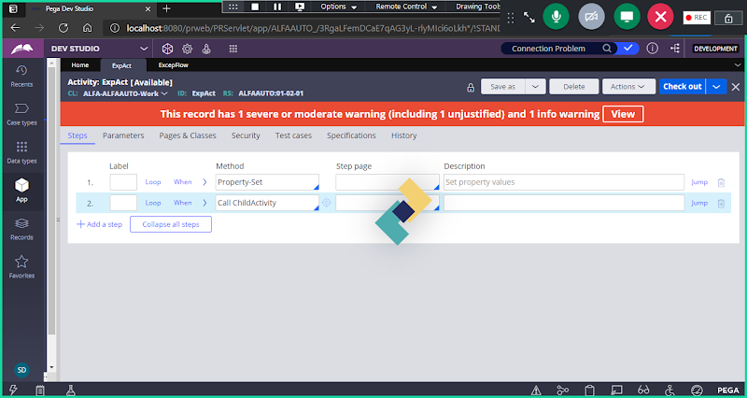

**Under Step1 -> Click on Jump Condition & Add Exception**

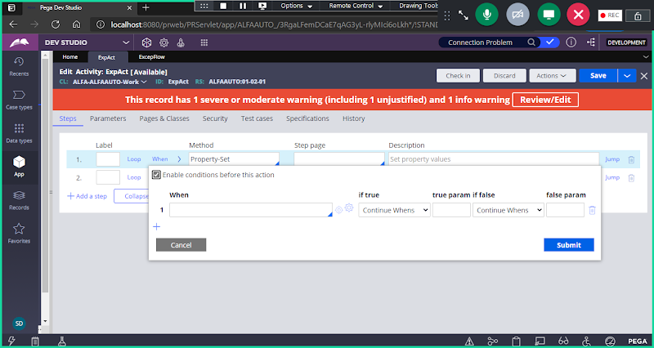

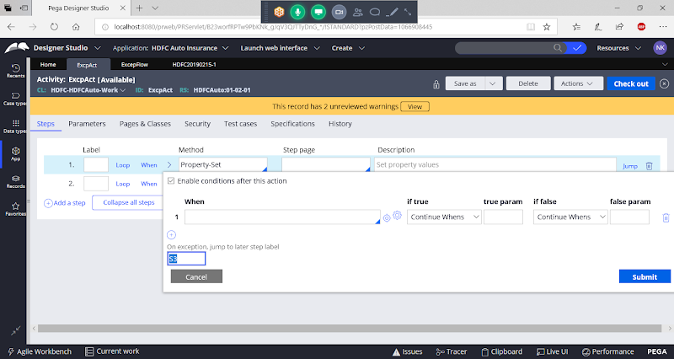

**Click on Submit**

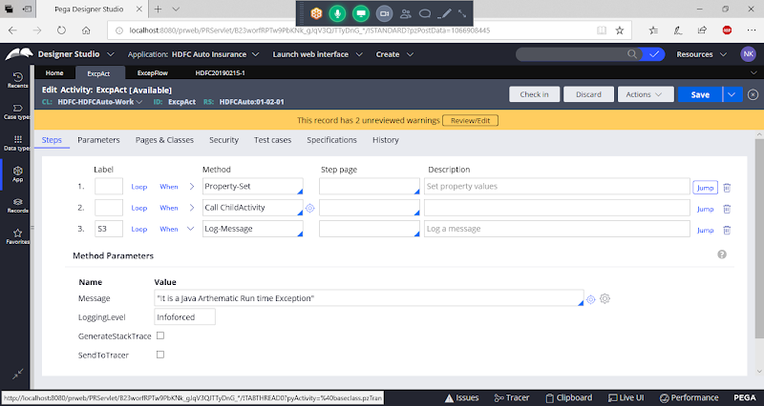

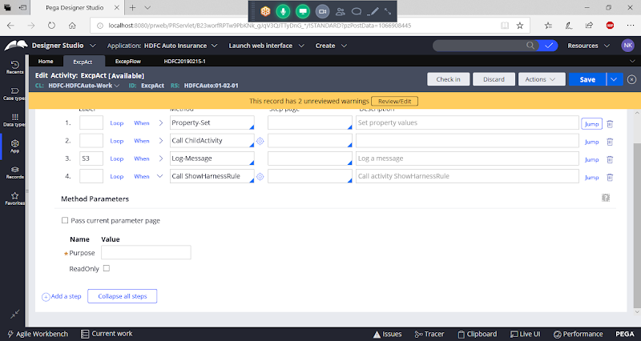

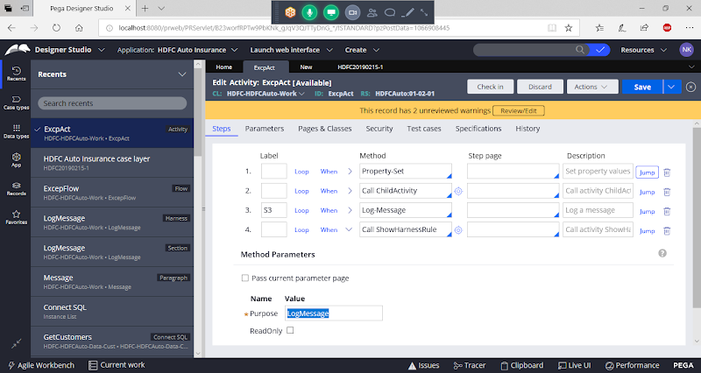

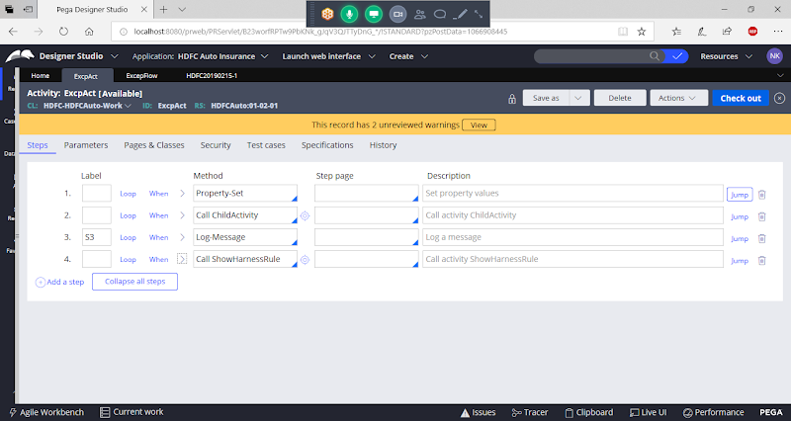

**Save Activity**

**Run Flow**



